UNITED STATES
SECURITIES AND EXCHANGE COMMISSION
WASHINGTON, D.C. 20549
________________________________________
FORM 8-K
________________________________________
CURRENT REPORT
PURSUANT TO SECTION 13 OR 15(d) OF THE SECURITIES EXCHANGE ACT OF 1934
August 5, 2026
Date of report (date of earliest event reported)
_________________________________________
Digi International Inc.
(Exact name of registrant as specified in its charter)
_________________________________________
Delaware |  |  |  |  |  | 1-34033 |  |  |  |  |  | 41-1532464
(State of Incorporation) |  |  |  |  |  | (Commission file number) |  |  |  |  |  | (I.R.S. Employer Identification No.)
9350 Excelsior Blvd. |  |  |  |  |  | Suite 700
Hopkins |  |  |  |  |  | Minnesota |  |  |  |  |  | 55343
(Address of principal executive offices) |  |  |  |  |  |  |  |  |  |  |  | (Zip Code)
(952) 912-3444
(Registrant’s telephone number, including area code)
________________________________________
Check the appropriate box below if the Form 8-K filing is intended to simultaneously satisfy the filing obligation of the registrant under any of the following provisions:
☐ |  |  | Written communications pursuant to Rule 425 under the Securities Act (17 CFR 230.425)
☐ |  |  | Soliciting material pursuant to Rule 14a-12 under the Exchange Act (17 CFR 240.14a-12)
☐ |  |  | Pre-commencement communications pursuant to Rule 14d-2(b) under the Exchange Act (17 CFR 240.14d-2(b))
☐ |  |  | Pre-commencement communications pursuant to Rule 13e-4(c) under the Exchange Act (17 CFR 240.13e-4(c))

Securities registered pursuant to Section 12(b) of the Act:
Title of each class |  |  |  |  |  | Trading Symbol |  |  |  |  |  | Name of each exchange on which registered
Common Stock, par value $.01 per share |  |  |  |  |  | DGII |  |  |  |  |  | The Nasdaq Stock Market LLC

Indicate by check mark whether the registrant is an emerging growth company as defined in as defined in Rule 405 of the Securities Act of 1933 (§ 230.405 of this chapter) or Rule 12b-2 of the Securities Exchange Act of 1934 (§ 240.12b-2 of this chapter).
Emerging growth company ☐
If an emerging growth company, indicate by check mark if the registrant has elected not to use the extended transition period for complying with any new or revised financial accounting standards provided pursuant to Section 13(a) of the Exchange Act. ☐

Item 2.02 |  |  | Results of Operations and Financial Condition.
On August 5, 2026, Digi International Inc. (“Digi”) issued a press release and investor deck regarding Digi’s financial results for its third fiscal quarter ended June 30, 2026. A copy of Digi’s press release is attached hereto as Exhibit 99.1 and a copy of Digi's investor deck as Exhibit 99.2.
The information contained in this Current Report shall not be deemed “filed” for purposes of Section 18 of the Securities Exchange Act of 1934, as amended (the “Exchange Act”), or incorporated by reference in any filing under the Securities Act of 1933, as amended, or the Exchange Act, except as shall be expressly set forth by specific reference in such a filing.
Item 9.01 |  |  | Financial Statements and Exhibits.
No. |  |  |  |  |  | Exhibit |  |  |  |  |  | Manner of Filing
99.1 |  |  |  |  |  | Press Release dated August 5, 2026, announcing financial results for the third fiscal quarter ended June 30, 2026 |  |  |  |  |  | Furnished Electronically
99.2 |  |  |  |  |  | Investor Deck dated August 5, 2026, announcing financial results for the third fiscal quarter ended June 30, 2026 |  |  |  |  |  | Furnished Electronically
104 |  |  |  |  |  | The cover page from the Current Report on Form 8-K formatted in Inline XBRL |  |  |  |  |  | Filed Electronically

SIGNATURES
Pursuant to the requirements of the Securities and Exchange Act of 1934, the registrant has duly caused this report to be signed on its behalf by the undersigned duly authorized.
Date: August 5, 2026

 |  |  | DIGI INTERNATIONAL INC.
 |  |  | By: |  |  |  |  |  | /s/ James J. Loch
 |  |  |  |  |  |  |  |  | James J. Loch
 |  |  |  |  |  |  |  |  | Senior Vice President, Chief Financial Officer and Treasurer

Exhibit 99.1



Digi International Reports Third Fiscal Quarter 2026 Results
Record Quarterly Revenue of $139M, Record End of Quarter ARR of $191M
Quarterly Cash Flow From Operations of $33M
(Minneapolis, MN, August 5, 2026) - Digi International Inc. ("Digi" or the "Company") (Nasdaq: DGII), a leading global provider of business and mission-critical Internet of Things ("IoT") products, services and solutions, today announced its financial results for its third fiscal quarter ended June 30, 2026.

Third Fiscal Quarter 2026 Results Compared to Third Fiscal Quarter 2025 Results1

•Revenue was $139 million, an increase of 29%.

•Gross profit margin was 64.8%, an increase of 130 basis points.

•Operating margin was 16.5%, an increase of 260 basis points.

•Net income was $16 million, an increase of 54%.

•Net income per diluted share was $0.40, an increase of 48%.

•Adjusted net income was $29 million, an increase of 50%.

•Adjusted net income per diluted share was $0.75, an increase of 47%.

•Adjusted EBITDA was $40 million, an increase of 47%.

•Annualized Recurring Revenue ("ARR") was $191 million at quarter end, an increase of 52%.

(1) Fiscal 2026 results include the results of Jolt Software, Inc. ("Jolt") for the full quarter and nine-month period and Particle Industries, Inc. ("Particle") following the January 2026 acquisition date. Fiscal 2025 results include Jolt for the period following the August acquisition date and do not include Particle.

Reconciliations of non-GAAP financial measures to their closest GAAP analogs appear at the end of this release, as well as a discussion of recent changes to the method of calculating adjusted net income and adjusted net income per share.

"Digi set new records for revenue, end of quarter ARR, and profit in our fiscal third quarter," stated Ron Konezny, President and CEO. "Growth in ARR reflects achieving ROI for our customers through remote presence and control over their mission-critical and business-critical assets. Strong execution across the Company is creating operating leverage. Cash generation remained strong in the quarter, further strengthening our balance sheet and enhancing our acquisition flywheel."

Digi International Reports Third Fiscal Quarter 2026 Results
Additional Financial Highlights

•Our outstanding debt as of the end of the third quarter was $109 million and our cash and cash equivalents balance was $28 million, resulting in a debt net of cash and cash equivalents of $81 million.

•Cash flow from operations was $33 million in the third quarter of fiscal 2026, compared to $24 million in the third quarter of fiscal 2025. This change was driven primarily by a decrease in deferred income tax benefits, relating to accelerated utilization of tax assets caused by the One Big Beautiful Bill Act.
Segment Results
IoT Product & Services
The segment's third fiscal quarter 2026 revenue of $100 million increased 25% compared to the same period in the prior fiscal year. This consisted of a $12.4 million increase in one-time sales and $7.4 million of recurring revenue growth, with no material impact from pricing. A significant majority of the increase in revenue was driven by organic growth from increased customer demand and supported by the Particle acquisition. ARR as of the end of the third fiscal quarter was $60 million, an increase of 100% from the end of the third fiscal quarter of 2025. This increase was driven primarily by the acquisition of Particle and supported by growth in the subscription base across remote management platforms, extended warranty offerings and technical support. Operating margin increased 160 basis points to 16.8% of revenue for the third fiscal quarter of 2026, was primarily due to heightened inventory-related costs in the prior year that did not repeat and improved operating expense efficiencies as volume expanded at a greater rate than operating expenses.
IoT Solutions
The segment's third fiscal quarter 2026 revenue of $39 million increased 41%, as compared to the same period in the prior fiscal year. The increase consisted of an $8.9 million increase in recurring revenue and a $2.5 million increase in one-time sales, with the significant majority of both driven by the Jolt acquisition. ARR as of the end of the third fiscal quarter was $131 million, an increase of 36% from the end of the third fiscal quarter of 2025, driven by the acquisition of Jolt, as well as growth in our existing Solutions businesses. Operating margins increased 570 basis points to 15.7% in the third fiscal quarter of 2026 compared to the prior fiscal year. This increase was the result of improved operating expense efficiencies as volume expanded at a greater rate than operating expenses.
Capital Allocation Strategy
We intend to continue to deleverage the Company's balance sheet.
Acquisitions remain a top capital priority for Digi as reflected by our acquisition of Particle announced on January 27.
We will continue to be disciplined in our approach and act when we believe an opportunity is appropriate to execute in the context of prevailing market conditions.
2
Digi International Reports Third Fiscal Quarter 2026 Results
Fourth Fiscal Quarter & Full Year Fiscal 2026 Guidance
The shift toward software-driven connected operations continues to generate durable demand for hardware-enabled software solutions that support our customers' most critical business needs. Legacy "set it and forget it" infrastructure increasingly fails to meet the operational, regulatory, and competitive demands organizations face today. Customers across industrial, infrastructure, and enterprise markets are prioritizing connectivity, intelligence at the edge, and software capabilities as fundamental enablers of their strategic roadmaps. With industrial activity strengthening broadly and investment accelerating across automation, energy, and data infrastructure, customers are treating these capabilities as essential infrastructure rather than discretionary spending. Digi is well-positioned to capture that demand, even as we manage an evolving global trade framework and rising component costs — most notably memory — through disciplined pricing, supply-chain agility, and the resilience of our recurring revenue model.
Our focus is on solutions that generate recurring revenue streams and create compounding value for customers well beyond the initial device purchase. The performance we are reporting today, and our raised outlook for the year, reflects the benefits of this model, which insulates our margin structure in ways purely hardware-dependent businesses cannot match. ARR growth, margin expansion, and customer retention trends all reinforce our confidence in achieving $200 million in both ARR and Adjusted EBITDA within our targeted time horizon. Strategic acquisitions aligned with these objectives remain a tool to accelerate our path.
For fiscal 2026, we now anticipate ARR growth of at least 27% versus fiscal 2025, up from our prior guidance of growth of 25%. Revenue is estimated to be $529 million to $533 million for fiscal 2026, representing growth of 23-24% versus fiscal 2025, up from our prior guidance of growth of 20-22%. Adjusted EBITDA is estimated to be $146.0 million to $147.5 million, representing growth of 35-36% versus fiscal 2025, up from our prior guidance of growth of 23-26%.
For the fourth fiscal quarter, revenues are estimated to be $138 million to $142 million. Adjusted EBITDA is estimated to be between $40.0 and $41.5 million. Beginning in fiscal 2026, our adjusted net income per diluted share metric includes interest expense. Prior period figures have been recast for comparability. Adjusted net income per diluted share is anticipated to be between $0.75 and $0.78 per diluted share, assuming a weighted average diluted share count of 39.1 million. This includes an expected impact from interest between $0.02 and $0.03 per diluted share.
We provide guidance or longer-term targets for Adjusted net income per share as well as Adjusted EBITDA targets on a non-GAAP basis. We do not reconcile these items to their most comparable U.S. GAAP measure as it is not possible to predict without unreasonable efforts numerous items that include but are not limited to the impact of foreign exchange translation, restructuring, interest and certain tax-related events. Given the uncertainty, any of these items could have a significant impact on U.S. GAAP results.
Third Fiscal Quarter 2026 Video Conference Call Details
As announced on July 7, 2026, Digi will discuss its third fiscal quarter results on a video conference call on Wednesday, August 5, 2026 at approximately 5:00 p.m. ET (4:00 p.m. CT). The call will be hosted by Ron Konezny, President and Chief Executive Officer and Jamie Loch, Chief Financial Officer.
Participants may register for the video conference call at: https://register-conf.media-server.com/register/BI31bab22d020441949bd463d2db180804. Once registration is completed, participants will be provided a dial in number and passcode to access the call. All participants are asked to dial-in 15 minutes prior to the start time.
Participants may access a live webcast of the video conference call through the investor relations section of Digi’s website, https://digi.gcs-web.com/ or the hosting website at: https://edge.media-server.com/mmc/p/nmm55mxb/.
A replay will be available within approximately two hours after the completion of the call for approximately one year. You may access the replay via webcast through the investor relations section of Digi’s website.
A copy of this earnings release can be accessed through the financial releases page of the investor relations section of Digi's website at www.digi.com.
For more news and information on us, please visit www.digi.com/aboutus/investorrelations.
About Digi International
Digi International Inc. (Nasdaq: DGII) is a leading global provider of IoT connectivity products, services and solutions. We help our customers create next-generation connected products and deploy and manage critical communications
3
Digi International Reports Third Fiscal Quarter 2026 Results
infrastructures in demanding environments with high levels of security and reliability. Founded in 1985, we’ve helped our customers connect over 100 million things and growing. For more information, visit Digi's website at www.digi.com.
Forward-Looking Statements
This press release contains "forward-looking statements" as that term is defined under the Private Securities Litigation Reform Act of 1995, and within the meaning of Section 27A of the Securities Act of 1933, as amended, and Section 21E of the Securities Exchange Act of 1934, as amended, that are based on management’s current expectations and assumptions. These statements often can be identified by the use of forward-looking terminology such as "assume," "believe," "continue," "estimate," "expect," "intend," "may," "remain," "plan," "potential," "project," "should," or "will" or the negative thereof or other variations thereon or similar terminology. Among other items, these statements relate to expectations of the business environment in which Digi operates, projections of future performance, including but not limited to expectations regarding the Company’s profitability and net cash position, inventory levels, perceived marketplace opportunities, debt repayments, attributions of actual or potential acquisitions and statements regarding our mission and vision. Such statements are not guarantees of future performance and involve certain risks, uncertainties and assumptions. Among others, these include risks related to our ability to realize synergies and operating benefits from completed acquisitions (like our recent acquisitions of Jolt completed in August 2025, and Particle completed in January 2026), ongoing and varying inflationary and deflationary pressures around the world and the monetary, fiscal and trade policies of governments globally as well as present and ongoing concerns about a potential economic slowdown, the potential for longer than expected sales cycles, the ability of companies like us to operate a global business in such conditions as well as negative effects on product demand and the financial solvency of customers and suppliers in such conditions, risks related to ongoing supply chain challenges, regulatory risks that include, but are not limited to, the potential expansion of tariffs and potential changes to regulations impacting the functionality or compliance of our products, risks related to cybersecurity, data breaches and data privacy, risks arising from military conflicts such as those in Ukraine, the Middle East,and geopolitical tensions including those involving China and Taiwan, the highly competitive market in which we operate, rapid changes in technologies that may displace products sold by us, declining prices of networking products, our reliance on distributors and other third parties to sell our products, the potential for significant purchase orders to be canceled or changed, delays in product development efforts, uncertainty in user acceptance of our products, the ability to integrate our products and services with those of other parties in a commercially accepted manner, potential liabilities that can arise if any of our products have design or manufacturing defects, our ability to defend or settle satisfactorily any litigation, the impact of natural disasters and other events beyond our control that could negatively impact our supply chain and customers, potential unintended consequences associated with restructuring, reorganizations or other similar business initiatives that may impact our ability to retain important employees or otherwise impact our operations in unintended and adverse ways, and changes in our level of revenue or profitability which can fluctuate for many reasons beyond our control. These and other risks, uncertainties and assumptions identified from time to time in our filings with the United States Securities and Exchange Commission, including without limitation, those set forth in Item 1A, Risk Factors, of our Annual Report on Form 10-K for the year ended September 30, 2025, and any other subsequent filings, could cause our actual results to differ materially from those expressed in any forward-looking statements made by us or on our behalf. Many of such factors are beyond our ability to control or predict. These forward-looking statements speak only as of the date for which they are made. Except to the extent required by law, we do not undertake, and expressly disclaim, any intent or obligation to update any forward-looking statements, whether as a result of new information, future events or otherwise.

4
Digi International Reports Third Fiscal Quarter 2026 Results
Presentation of Non-GAAP Financial Measures
This release includes adjusted net income, adjusted net income per diluted share and Adjusted EBITDA (defined below), each of which is a non-GAAP measure.
During the first fiscal quarter of 2026, Digi modified its method of calculating adjusted net income and adjusted net income per share to include the impact of interest expense. This change was primarily driven by the continued use of financing by the Company to fund cash flow needs and therefore including the recurring nature of interest presents a better metric by which management believes provides a more representative view of operating performance and cash-generating capability. Accordingly, we evaluated the impact of this change on prior-period disclosures and have recast adjusted net income and adjusted net income per share for all periods to conform to this presentation.
We understand that there are material limitations on the use of non-GAAP measures. Non-GAAP measures are not substitutes for GAAP measures, such as net income, for the purpose of analyzing financial performance. The disclosure of these measures does not reflect all charges and gains that actually were recognized by Digi. These non-GAAP measures are not in accordance with, or an alternative for measures prepared in accordance with, generally accepted accounting principles and may be different from non-GAAP measures used by other companies or presented by us in prior reports. In addition, these non-GAAP measures are not based on any comprehensive set of accounting rules or principles. We believe that non-GAAP measures have limitations in that they do not reflect all of the amounts associated with our results of operations as determined in accordance with GAAP. We believe these measures should only be used to evaluate our results of operations in conjunction with the corresponding GAAP measures. Additionally, Adjusted EBITDA and Adjusted EBITDA Margin do not reflect our cash expenditures, the cash requirements for the replacement of depreciated and amortized assets, or changes in or cash requirements for our working capital needs.
We believe that providing historical and adjusted net income and adjusted net income per diluted share, respectively, exclusive of such items as reversals of tax reserves, discrete tax benefits, restructuring charges and reversals, intangible amortization, stock-based compensation, other non-operating income/expense and acquisition-related expenses related to acquisitions permits investors to compare results with prior periods that did not include these items. Management uses the aforementioned non-GAAP measures to monitor and evaluate ongoing operating results and trends and to gain an understanding of our comparative operating performance. In addition, certain of our stockholders have expressed an interest in seeing financial performance measures exclusive of the impact of these matters, which while important, are not central to the core operations of our business. Management believes that "Adjusted EBITDA", defined as EBITDA adjusted for stock-based compensation expense, acquisition-related expenses and restructuring charges and reversals is useful to investors to evaluate our core operating results and financial performance because it excludes items that are significant non-cash or non-recurring items reflected in the Condensed Consolidated Statements of Operations. We believe that presenting Adjusted EBITDA as a percentage of revenue (i.e., Adjusted EBITDA Margin) is useful because it provides a reliable and consistent approach to measuring our performance year over year and in assessing our performance against that of other companies. We believe this information helps compare operating results and corporate performance exclusive of the impact of our capital structure and the method by which assets were acquired.

5
Digi International Reports Third Fiscal Quarter 2026 Results

Investor Contact:
Rob Bennett
Investor Relations
Digi International
952-912-3524
Email: rob.bennett@digi.com

6
Digi International Reports Third Fiscal Quarter 2026 Results
Digi International Inc.
Condensed Consolidated Statements of Operations
(In thousands, except per share amounts)
(Unaudited)
 |  |  | Three months ended June 30, |  |  |  |  |  |  |  |  |  |  |  | Nine months ended June 30,
 |  |  | 2026 |  |  |  |  |  | 2025 |  |  |  |  |  | 2026 |  |  |  |  |  | 2025
Revenue |  |  | $ | 138,670 |  |  |  |  | $ | 107,514 |  |  |  |  | $ | 391,875 |  |  |  |  | $ | 315,883
Cost of sales |  |  | 48,744 |  |  |  |  |  | 39,246 |  |  |  |  |  | 141,883 |  |  |  |  |  | 118,284
Gross profit |  |  | 89,926 |  |  |  |  |  | 68,268 |  |  |  |  |  | 249,992 |  |  |  |  |  | 197,599
Operating expenses:
Sales and marketing |  |  | 29,061 |  |  |  |  |  | 23,019 |  |  |  |  |  | 82,564 |  |  |  |  |  | 66,817
Research and development |  |  | 20,325 |  |  |  |  |  | 16,227 |  |  |  |  |  | 56,759 |  |  |  |  |  | 46,579
General and administrative |  |  | 17,645 |  |  |  |  |  | 14,099 |  |  |  |  |  | 54,375 |  |  |  |  |  | 42,194
Operating expenses |  |  | 67,031 |  |  |  |  |  | 53,345 |  |  |  |  |  | 193,698 |  |  |  |  |  | 155,590
Operating income |  |  | 22,895 |  |  |  |  |  | 14,923 |  |  |  |  |  | 56,294 |  |  |  |  |  | 42,009
Other expense, net |  |  | (1,637) |  |  |  |  |  | (963) |  |  |  |  |  | (6,208) |  |  |  |  |  | (4,605)
Income before income taxes |  |  | 21,258 |  |  |  |  |  | 13,960 |  |  |  |  |  | 50,086 |  |  |  |  |  | 37,404
Income tax provision |  |  | 5,518 |  |  |  |  |  | 3,717 |  |  |  |  |  | 11,332 |  |  |  |  |  | 6,581
Net income |  |  | $ | 15,740 |  |  |  |  | $ | 10,243 |  |  |  |  | $ | 38,754 |  |  |  |  | $ | 30,823
Net income per common share:
Basic |  |  | $ | 0.42 |  |  |  |  | $ | 0.28 |  |  |  |  | $ | 1.03 |  |  |  |  | $ | 0.84
Diluted |  |  | $ | 0.40 |  |  |  |  | $ | 0.27 |  |  |  |  | $ | 1.00 |  |  |  |  | $ | 0.82
Weighted average common shares:
Basic |  |  | 37,776 |  |  |  |  |  | 37,073 |  |  |  |  |  | 37,588 |  |  |  |  |  | 36,902
Diluted |  |  | 38,919 |  |  |  |  |  | 37,653 |  |  |  |  |  | 38,646 |  |  |  |  |  | 37,623

7
Digi International Reports Third Fiscal Quarter 2026 Results
Digi International Inc.
Condensed Consolidated Balance Sheets
(In thousands)
(Unaudited)
 |  |  | June 30,  2026 |  |  |  |  |  | September 30,  2025
ASSETS
Current assets:
Cash and cash equivalents |  |  | $ | 27,972 |  |  |  |  | $ | 21,902
Accounts receivable, net |  |  | 62,787 |  |  |  |  |  | 63,453
Inventories |  |  | 45,010 |  |  |  |  |  | 38,911
Income taxes receivable |  |  | 3,824 |  |  |  |  |  | 1,875
Prepaid expenses and other current assets |  |  | 5,669 |  |  |  |  |  | 4,558
Total current assets |  |  | 145,262 |  |  |  |  |  | 130,699
Non-current assets |  |  | 819,089 |  |  |  |  |  | 791,947
Total assets |  |  | $ | 964,351 |  |  |  |  | $ | 922,646
LIABILITIES AND STOCKHOLDERS’ EQUITY
Current liabilities:
Accounts payable |  |  | 35,099 |  |  |  |  |  | 35,871
Other current liabilities |  |  | 93,592 |  |  |  |  |  | 71,939
Total current liabilities |  |  | 128,691 |  |  |  |  |  | 107,810
Long-term debt |  |  | 108,130 |  |  |  |  |  | 159,152
Other non-current liabilities |  |  | 42,377 |  |  |  |  |  | 19,607
Non-current liabilities |  |  | 150,507 |  |  |  |  |  | 178,759
Total liabilities |  |  | 279,198 |  |  |  |  |  | 286,569
Total stockholders’ equity |  |  | 685,153 |  |  |  |  |  | 636,077
Total liabilities and stockholders’ equity |  |  | $ | 964,351 |  |  |  |  | $ | 922,646

Digi International Inc.
Condensed Consolidated Statements of Cash Flows
(In thousands)
(Unaudited)
 |  |  | Nine months ended June 30,
 |  |  | 2026 |  |  |  |  |  | 2025
Net cash provided by operating activities |  |  | $ | 110,419 |  |  |  |  | $ | 79,958
Net cash used in investing activities |  |  | (50,568) |  |  |  |  |  | (2,148)
Net cash used in financing activities |  |  | (53,553) |  |  |  |  |  | (85,291)
Effect of exchange rate changes on cash and cash equivalents |  |  | (228) |  |  |  |  |  | 75
Net increase (decrease) in cash and cash equivalents |  |  | 6,070 |  |  |  |  |  | (7,406)
Cash and cash equivalents, beginning of period |  |  | 21,902 |  |  |  |  |  | 27,510
Cash and cash equivalents, end of period |  |  | $ | 27,972 |  |  |  |  | $ | 20,104

8
Digi International Reports Third Fiscal Quarter 2026 Results
Non-GAAP Financial Measures
TABLE 1
Reconciliation of Net Income to Adjusted EBITDA
(In thousands)
 |  |  | Three months ended June 30, |  |  |  |  |  |  |  |  |  |  |  |  |  |  |  |  |  |  |  |  |  |  |  | Nine months ended June 30,
 |  |  | 2026 |  |  |  |  |  |  |  |  |  |  |  | 2025 |  |  |  |  |  |  |  |  |  |  |  | 2026 |  |  |  |  |  |  |  |  |  |  |  | 2025
 |  |  |  |  |  |  |  |  | % of total  revenue |  |  |  |  |  |  |  |  |  |  |  | % of total  revenue |  |  |  |  |  |  |  |  |  |  |  | % of total  revenue |  |  |  |  |  |  |  |  |  |  |  | % of total  revenue
Total revenue |  |  | $ | 138,670 |  |  |  |  | 100.0 |  | % |  |  |  | $ | 107,514 |  |  |  |  | 100.0 |  | % |  |  |  | $ | 391,875 |  |  |  |  | 100.0 |  | % |  |  |  | $ | 315,883 |  |  |  |  | 100.0 |  | %
Net income |  |  | $ | 15,740 |  |  |  |  |  |  |  |  |  |  | $ | 10,243 |  |  |  |  |  |  |  |  |  |  | $ | 38,754 |  |  |  |  |  |  |  |  |  |  | $ | 30,823
Interest expense, net |  |  | 1,606 |  |  |  |  |  |  |  |  |  |  |  | 932 |  |  |  |  |  |  |  |  |  |  |  | 6,129 |  |  |  |  |  |  |  |  |  |  |  | 4,562
Income tax provision |  |  | 5,518 |  |  |  |  |  |  |  |  |  |  |  | 3,717 |  |  |  |  |  |  |  |  |  |  |  | 11,332 |  |  |  |  |  |  |  |  |  |  |  | 6,581
Depreciation and amortization |  |  | 11,470 |  |  |  |  |  |  |  |  |  |  |  | 8,301 |  |  |  |  |  |  |  |  |  |  |  | 32,997 |  |  |  |  |  |  |  |  |  |  |  | 24,963
Stock-based compensation expense |  |  | 4,917 |  |  |  |  |  |  |  |  |  |  |  | 3,874 |  |  |  |  |  |  |  |  |  |  |  | 13,411 |  |  |  |  |  |  |  |  |  |  |  | 11,378
Loss (gain) on asset sale |  |  | 50 |  |  |  |  |  |  |  |  |  |  |  | (181) |  |  |  |  |  |  |  |  |  |  |  | (150) |  |  |  |  |  |  |  |  |  |  |  | (181)
Restructuring charge |  |  | 274 |  |  |  |  |  |  |  |  |  |  |  | 76 |  |  |  |  |  |  |  |  |  |  |  | 772 |  |  |  |  |  |  |  |  |  |  |  | 460
Acquisition expense, net |  |  | 813 |  |  |  |  |  |  |  |  |  |  |  | 597 |  |  |  |  |  |  |  |  |  |  |  | 3,119 |  |  |  |  |  |  |  |  |  |  |  | 597
Adjusted EBITDA |  |  | $ | 40,388 |  |  |  |  | 29.1 |  | % |  |  |  | $ | 27,559 |  |  |  |  | 25.6 |  | % |  |  |  | $ | 106,364 |  |  |  |  | 27.1 |  | % |  |  |  | $ | 79,183 |  |  |  |  | 25.1 |  | %
TABLE 2

Reconciliation of Net Income and Net Income per Diluted Share to
Adjusted Net Income and Adjusted Net Income per Diluted Share
(In thousands, except per share amounts)
 |  |  | Three months ended June 30, |  |  |  |  |  |  |  |  |  |  |  |  |  |  |  |  |  |  |  |  |  |  |  | Nine months ended June 30,
 |  |  | 2026 |  |  |  |  |  |  |  |  |  |  |  | 2025 |  |  |  |  |  |  |  |  |  |  |  | 2026 |  |  |  |  |  |  |  |  |  |  |  | 2025
Net income and net income per diluted share |  |  | $ | 15,740 |  |  |  |  | $ | 0.40 |  |  |  |  | $ | 10,243 |  |  |  |  | $ | 0.27 |  |  |  |  | $ | 38,754 |  |  |  |  | $ | 1.00 |  |  |  |  | $ | 30,823 |  |  |  |  | $ | 0.82
Amortization |  |  | 8,166 |  |  |  |  |  | 0.21 |  |  |  |  |  | 5,241 |  |  |  |  |  | 0.14 |  |  |  |  |  | 23,243 |  |  |  |  |  | 0.60 |  |  |  |  |  | 16,241 |  |  |  |  |  | 0.43
Stock-based compensation expense |  |  | 4,917 |  |  |  |  |  | 0.13 |  |  |  |  |  | 3,874 |  |  |  |  |  | 0.10 |  |  |  |  |  | 13,411 |  |  |  |  |  | 0.35 |  |  |  |  |  | 11,378 |  |  |  |  |  | 0.30
Other non-operating income |  |  | 31 |  |  |  |  |  | — |  |  |  |  |  | 31 |  |  |  |  |  | — |  |  |  |  |  | 79 |  |  |  |  |  | — |  |  |  |  |  | 43 |  |  |  |  |  | —
Acquisition expense, net |  |  | 813 |  |  |  |  |  | 0.02 |  |  |  |  |  | 597 |  |  |  |  |  | 0.02 |  |  |  |  |  | 3,119 |  |  |  |  |  | 0.08 |  |  |  |  |  | 597 |  |  |  |  |  | 0.02
Loss (gain) on asset sale |  |  | 50 |  |  |  |  |  | — |  |  |  |  |  | (181) |  |  |  |  |  | — |  |  |  |  |  | (150) |  |  |  |  |  | — |  |  |  |  |  | (181) |  |  |  |  |  | —
Restructuring charge |  |  | 274 |  |  |  |  |  | 0.01 |  |  |  |  |  | 76 |  |  |  |  |  | — |  |  |  |  |  | 772 |  |  |  |  |  | 0.02 |  |  |  |  |  | 460 |  |  |  |  |  | 0.01
Tax effect from the above adjustments (1) |  |  | (853) |  |  |  |  |  | (0.02) |  |  |  |  |  | (1,339) |  |  |  |  |  | (0.04) |  |  |  |  |  | (3,930) |  |  |  |  |  | (0.10) |  |  |  |  |  | (5,585) |  |  |  |  |  | (0.15)
Discrete tax benefits (2) |  |  | (22) |  |  |  |  |  | — |  |  |  |  |  | 809 |  |  |  |  |  | 0.02 |  |  |  |  |  | (1,040) |  |  |  |  |  | (0.03) |  |  |  |  |  | 298 |  |  |  |  |  | 0.01
Adjusted net income and adjusted net income per diluted share (3) |  |  | $ | 29,116 |  |  |  |  | $ | 0.75 |  |  |  |  | $ | 19,351 |  |  |  |  | $ | 0.51 |  |  |  |  | $ | 74,258 |  |  |  |  | $ | 1.92 |  |  |  |  | $ | 54,074 |  |  |  |  | $ | 1.44
Diluted weighted average common shares |  |  |  |  |  |  |  |  | 38,919 |  |  |  |  |  |  |  |  |  |  |  | 37,653 |  |  |  |  |  |  |  |  |  |  |  | 38,646 |  |  |  |  |  |  |  |  |  |  |  | 37,623
(1)The tax effect from the above adjustments assumes an estimated effective tax rate of 18.0% for fiscal 2026 and 2025 based on adjusted net income.
(2)For the three and nine months ended June 30, 2026 and 2025 discrete tax benefits are a result of changes in excess tax benefits recognized on stock compensation.
(3)Adjusted net income per diluted share may not add due to the use of rounded numbers.

9
Earnings Presentation Fiscal Third Quarter 2026 August 5, 2026 Nasdaq: DGII

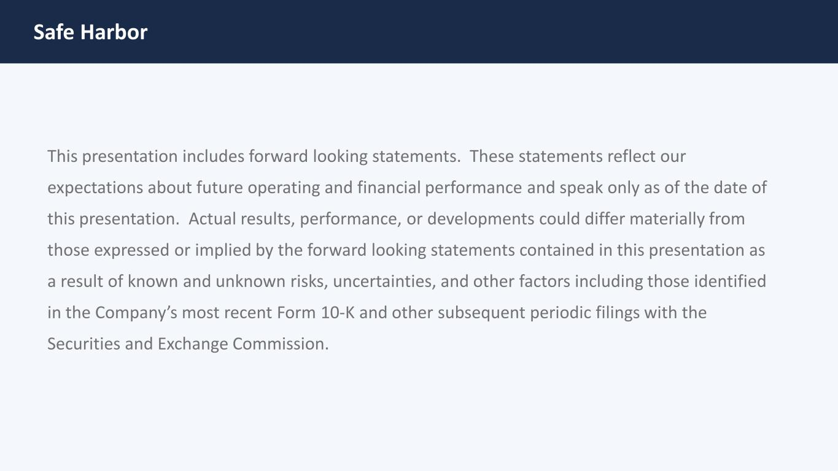
Safe Harbor This presentation includes forward looking statements. These statements reflect our expectations about future operating and financial performance and speak only as of the date of this presentation. Actual results, performance, or developments could differ materially from those expressed or implied by the forward looking statements contained in this presentation as a result of known and unknown risks, uncertainties, and other factors including those identified in the Company’s most recent Form 10‐K and other subsequent periodic filings with the Securities and Exchange Commission.


Digi Drives Value through Remote Presence

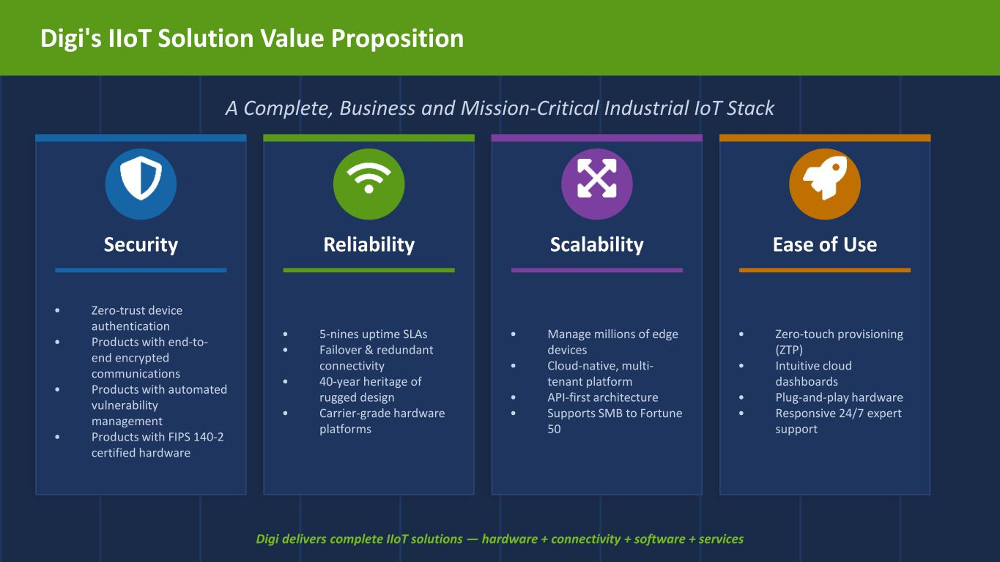
Digi's IIoT Solution Value Proposition A Complete, Business and Mission-Critical Industrial IoT Stack Security • Zero-trust device authentication • Products with end-to- end encrypted communications • Products with automated vulnerability management • Products with FIPS 140-2 certified hardware Reliability • 5-nines uptime SLAs • Failover & redundant connectivity • 40-year heritage of rugged design • Carrier-grade hardware platforms Scalability • Manage millions of edge devices • Cloud-native, multi- tenant platform • API-first architecture • Supports SMB to Fortune 50 Ease of Use • Zero-touch provisioning (ZTP) • Intuitive cloud dashboards • Plug-and-play hardware • Responsive 24/7 expert support Digi delivers complete IIoT solutions — hardware + connectivity + software + services


DANI – AI Assistant Inside Digi Remote Manager

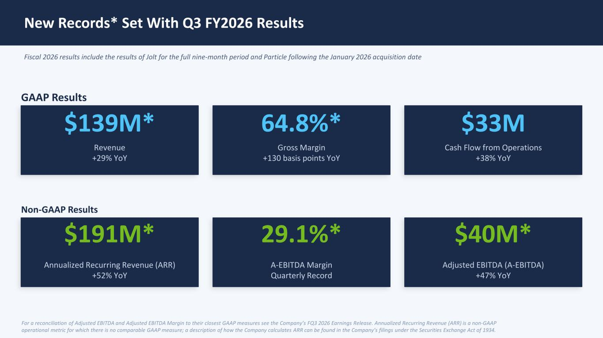
New Records* Set With Q3 FY2026 Results Fiscal 2026 results include the results of Jolt for the full nine-month period and Particle following the January 2026 acquisition date GAAP Results $139M* Revenue +29% YoY 64.8%* Gross Margin +130 basis points YoY $33M Cash Flow from Operations +38% YoY Non-GAAP Results $191M* Annualized Recurring Revenue (ARR) +52% YoY 29.1%* A-EBITDA Margin Quarterly Record $40M* Adjusted EBITDA (A-EBITDA) +47% YoY For a reconciliation of Adjusted EBITDA and Adjusted EBITDA Margin to their closest GAAP measures see the Company’s FQ3 2026 Earnings Release. Annualized Recurring Revenue (ARR) is a non-GAAP operational metric for which there is no comparable GAAP measure; a description of how the Company calculates ARR can be found in the Company’s filings under the Securities Exchange Act of 1934.

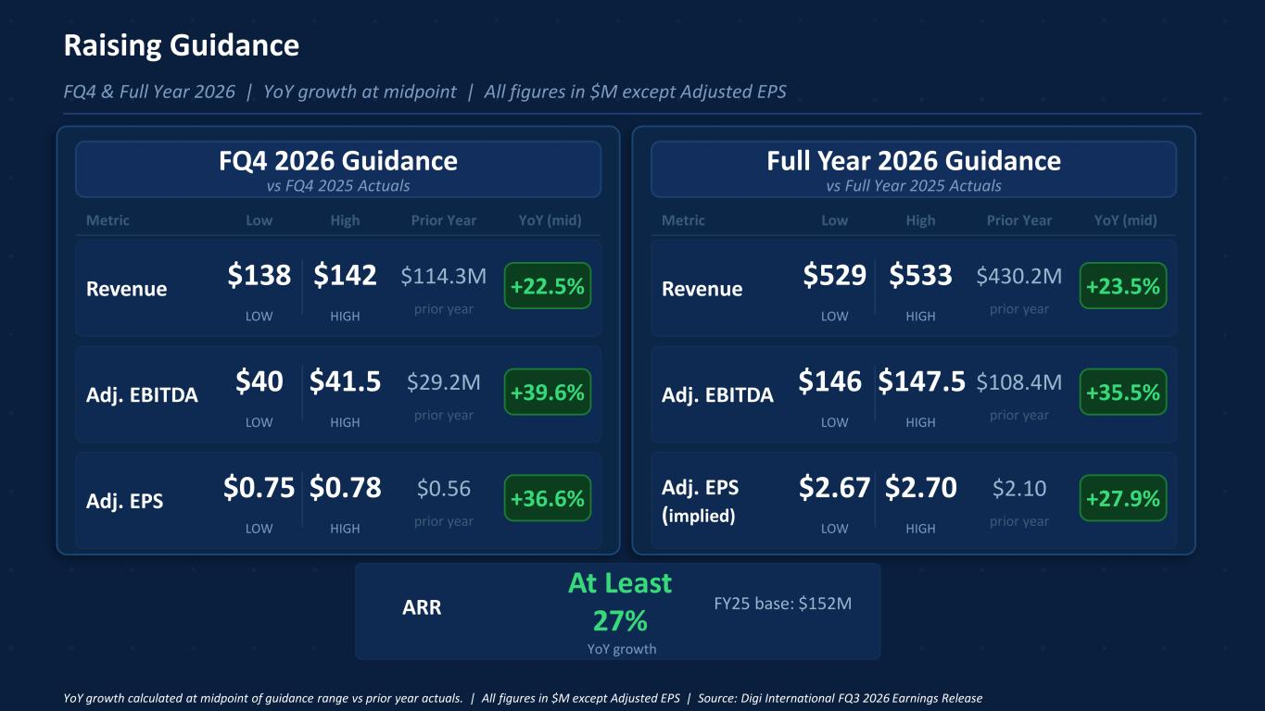
Raising Guidance FQ4 & Full Year 2026 | YoY growth at midpoint | All figures in $M except Adjusted EPS FQ4 2026 Guidance vs FQ4 2025 Actuals Full Year 2026 Guidance vs Full Year 2025 Actuals Metric Low High Prior Year YoY (mid) Metric Low High Prior Year YoY (mid) Revenue $138 LOW $142 HIGH $114.3M prior year +22.5% Adj. EBITDA $40 LOW $41.5 HIGH $29.2M prior year +39.6% Adj. EPS $0.75 LOW $0.78 HIGH $0.56 prior year +36.6% ARR At Least 27% YoY growth FY25 base: $152M Revenue $529 LOW $533 HIGH $430.2M prior year +23.5% Adj. EBITDA $146 LOW $147.5 HIGH $108.4M prior year +35.5% Adj. EPS (implied) $2.67 LOW $2.70 HIGH $2.10 prior year +27.9% YoY growth calculated at midpoint of guidance range vs prior year actuals. | All figures in $M except Adjusted EPS | Source: Digi International FQ3 2026 Earnings Release

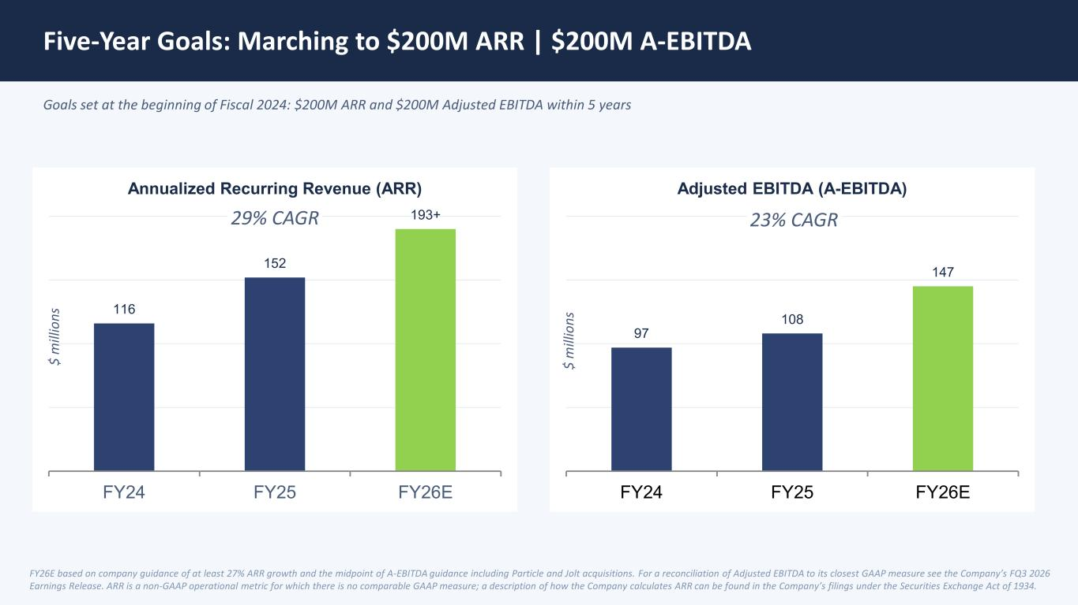
Five-Year Goals: Marching to $200M ARR | $200M A-EBITDA Goals set at the beginning of Fiscal 2024: $200M ARR and $200M Adjusted EBITDA within 5 years 116 152 193+ FY24 FY25 FY26E Annualized Recurring Revenue (ARR) 97 108 147 FY24 FY25 FY26E Adjusted EBITDA (A-EBITDA) FY26E based on company guidance of at least 27% ARR growth and the midpoint of A-EBITDA guidance including Particle and Jolt acquisitions. For a reconciliation of Adjusted EBITDA to its closest GAAP measure see the Company’s FQ3 2026 Earnings Release. ARR is a non-GAAP operational metric for which there is no comparable GAAP measure; a description of how the Company calculates ARR can be found in the Company’s filings under the Securities Exchange Act of 1934. 23% CAGR29% CAGR $ m ill io ns $ m ill io ns

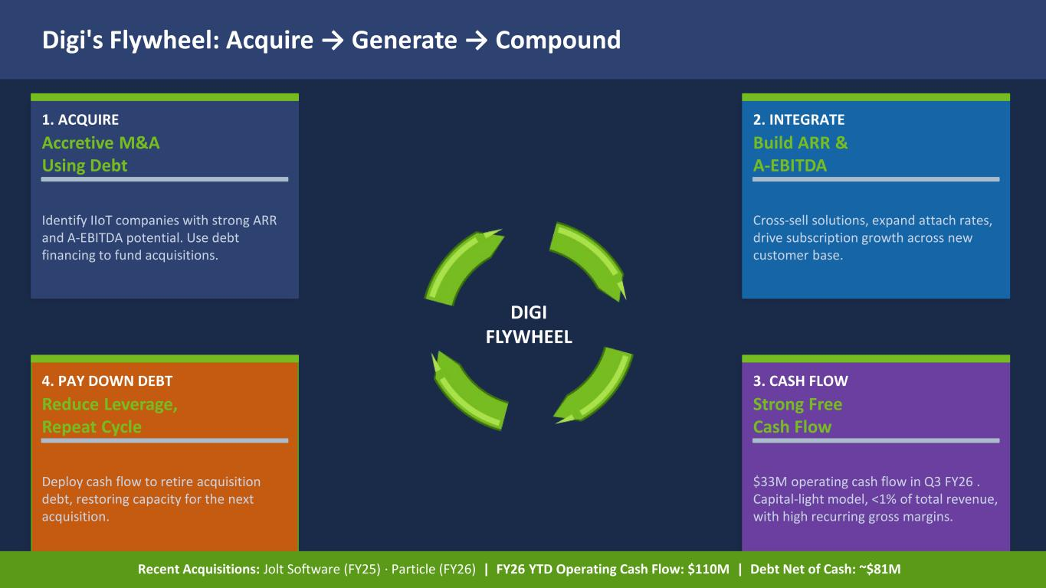
Digi's Flywheel: Acquire → Generate → Compound DIGI FLYWHEEL 1. ACQUIRE Accretive M&A Using Debt Identify IIoT companies with strong ARR and A-EBITDA potential. Use debt financing to fund acquisitions. 2. INTEGRATE Build ARR & A-EBITDA Cross-sell solutions, expand attach rates, drive subscription growth across new customer base. 3. CASH FLOW Strong Free Cash Flow $33M operating cash flow in Q3 FY26 . Capital-light model, <1% of total revenue, with high recurring gross margins. 4. PAY DOWN DEBT Reduce Leverage, Repeat Cycle Deploy cash flow to retire acquisition debt, restoring capacity for the next acquisition. Recent Acquisitions: Jolt Software (FY25) · Particle (FY26) | FY26 YTD Operating Cash Flow: $110M | Debt Net of Cash: ~$81M



