UNITED STATES
SECURITIES AND EXCHANGE COMMISSION
WASHINGTON, D.C. 20549
________________________________________
FORM 8-K
________________________________________
CURRENT REPORT
PURSUANT TO SECTION 13 OR 15(d) OF THE SECURITIES EXCHANGE ACT OF 1934
May 6, 2026
Date of report (date of earliest event reported)
_________________________________________
Digi International Inc.
(Exact name of registrant as specified in its charter)
_________________________________________
Delaware |  |  |  |  |  | 1-34033 |  |  |  |  |  | 41-1532464
(State of Incorporation) |  |  |  |  |  | (Commission file number) |  |  |  |  |  | (I.R.S. Employer Identification No.)
9350 Excelsior Blvd. |  |  |  |  |  | Suite 700
Hopkins |  |  |  |  |  | Minnesota |  |  |  |  |  | 55343
(Address of principal executive offices) |  |  |  |  |  |  |  |  |  |  |  | (Zip Code)
(952) 912-3444
(Registrant’s telephone number, including area code)
________________________________________
Check the appropriate box below if the Form 8-K filing is intended to simultaneously satisfy the filing obligation of the registrant under any of the following provisions:
☐ |  |  | Written communications pursuant to Rule 425 under the Securities Act (17 CFR 230.425)
☐ |  |  | Soliciting material pursuant to Rule 14a-12 under the Exchange Act (17 CFR 240.14a-12)
☐ |  |  | Pre-commencement communications pursuant to Rule 14d-2(b) under the Exchange Act (17 CFR 240.14d-2(b))
☐ |  |  | Pre-commencement communications pursuant to Rule 13e-4(c) under the Exchange Act (17 CFR 240.13e-4(c))

Securities registered pursuant to Section 12(b) of the Act:
Title of each class |  |  |  |  |  | Trading Symbol |  |  |  |  |  | Name of each exchange on which registered
Common Stock, par value $.01 per share |  |  |  |  |  | DGII |  |  |  |  |  | The Nasdaq Stock Market LLC

Indicate by check mark whether the registrant is an emerging growth company as defined in as defined in Rule 405 of the Securities Act of 1933 (§ 230.405 of this chapter) or Rule 12b-2 of the Securities Exchange Act of 1934 (§ 240.12b-2 of this chapter).
Emerging growth company ☐
If an emerging growth company, indicate by check mark if the registrant has elected not to use the extended transition period for complying with any new or revised financial accounting standards provided pursuant to Section 13(a) of the Exchange Act. ☐

Item 2.02 |  |  | Results of Operations and Financial Condition.
On May 6, 2026, Digi International Inc. (“Digi”) issued a press release and investor deck regarding Digi’s financial results for its second fiscal quarter ended March 31, 2026. A copy of Digi’s press release is attached hereto as Exhibit 99.1 and a copy of Digi's investor deck as Exhibit 99.2.
The information contained in this Current Report shall not be deemed “filed” for purposes of Section 18 of the Securities Exchange Act of 1934, as amended (the “Exchange Act”), or incorporated by reference in any filing under the Securities Act of 1933, as amended, or the Exchange Act, except as shall be expressly set forth by specific reference in such a filing.
Item 9.01 |  |  | Financial Statements and Exhibits.
No. |  |  |  |  |  | Exhibit |  |  |  |  |  | Manner of Filing
99.1 |  |  |  |  |  | Press Release dated May 6, 2026, announcing financial results for the second fiscal quarter ended March 31, 2026 |  |  |  |  |  | Furnished Electronically
99.2 |  |  |  |  |  | Investor Deck dated May 6, 2026, announcing financial results for the second fiscal quarter ended March 31, 2026 |  |  |  |  |  | Furnished Electronically
104 |  |  |  |  |  | The cover page from the Current Report on Form 8-K formatted in Inline XBRL |  |  |  |  |  | Filed Electronically

SIGNATURES
Pursuant to the requirements of the Securities and Exchange Act of 1934, the registrant has duly caused this report to be signed on its behalf by the undersigned duly authorized.
Date: May 6, 2026

 |  |  | DIGI INTERNATIONAL INC.
 |  |  | By: |  |  |  |  |  | /s/ James J. Loch
 |  |  |  |  |  |  |  |  | James J. Loch
 |  |  |  |  |  |  |  |  | Senior Vice President, Chief Financial Officer and Treasurer

Exhibit 99.1



Digi International Reports Second Fiscal Quarter 2026 Results
Record Quarterly Revenue of $131M, Record End of Quarter ARR of $184M
Record Cash Flow From Operations of $41M
(Minneapolis, MN, May 6, 2026) - Digi International Inc. ("Digi" or the "Company") (Nasdaq: DGII), a leading global provider of business and mission-critical Internet of Things ("IoT") products, services and solutions, today announced its financial results for its second fiscal quarter ended March 31, 2026.

Second Fiscal Quarter 2026 Results Compared to Second Fiscal Quarter 2025 Results1

•Revenue was $131 million, an increase of 25%.

•Gross profit margin was 64.0%, an increase of 190 basis points.

•Operating margin was 13.1% in both periods.

•Net income was $11 million, an increase of 8%.

•Net income per diluted share was $0.29, an increase of 4%.

•Adjusted net income was $24 million, an increase of 33%.

•Adjusted net income per diluted share was $0.62, an increase of 29%.

•Adjusted EBITDA was $34 million, an increase of 32%.

•Annualized Recurring Revenue (ARR) was $184 million at quarter end, an increase of 50%.

(1) Fiscal 2026 results include the results of Jolt for the full six-month period and Particle following the January 2026 acquisition date.

Reconciliations of non-GAAP financial measures to their closest GAAP analogs appear at the end of this release, as well as a discussion of recent changes to the method of calculating adjusted net income and adjusted net income per share.

"Digi set new records for revenue, ARR, and profits in second fiscal quarter. Both of our reporting segments contributed with both organic and inorganic growth based on the successful integration of Jolt and Particle," stated Ron Konezny, President and CEO. "ARR growth reflects our customers' confidence in the recurring value of our solutions. Strong cash flow from operations underscores the capital efficiency of our business model and enables our acquisition flywheel. We are focused on our solution-oriented approach, driving real ROI for customers, and positioning Digi for continued long-term value creation."

Digi International Reports Second Fiscal Quarter 2026 Results
Additional Financial Highlights

•We used a combination of debt and cash on hand to fund our acquisition of Particle in the second quarter. Our outstanding debt as of the end of the second quarter was $143 million and our cash and cash equivalents balance was $32 million, resulting in a debt net of cash and cash equivalents of $111 million.

•Cash flow from operations was $41 million in the second quarter of fiscal 2026, compared to $26 million in the second quarter of fiscal 2025. This change was driven primarily by a decrease in net operating assets in the second quarter of fiscal 2026 of $15 million compared to a decrease of $4.5 million in the prior year period.
Segment Results
IoT Product & Services
The segment's second fiscal quarter 2026 revenue of $94 million increased 20% compared to the same period in the prior fiscal year. This consisted of a $10.3 million increase in one-time sales and $5.5 million of recurring revenue growth, with no material impact from pricing. These increases were driven largely by organic growth, with a contribution from the Particle acquisition. ARR as of the end of the second fiscal quarter was $57 million, an increase of 104% from the end of the second fiscal quarter of 2025. This increase was primarily due to the acquisition of Particle, with additional growth in the subscription base across remote management platforms, extended warranty offerings and technical support. Operating margin increased 40 basis points to 14.9% of revenue for the second fiscal quarter of 2026, due to lower manufacturing related costs, partially offset by an increase in amortization expense, due to the addition of acquisition-related intangibles
IoT Solutions
The segment's second fiscal quarter 2026 revenue of $37 million increased 39%, as compared to the same period in the prior fiscal year. The increase consisted of a $7.8 million increase in recurring revenue and a $2.6 million increase in one-time sales, with the majority of both driven by the Jolt acquisition. ARR as of the end of the second fiscal quarter was $127 million, an increase of 34% from the end of the second fiscal quarter of 2025, driven primarily by the acquisition of Jolt,with additional growth in our existing Solutions businesses. Operating margins decreased 80 basis points to 8.3% in the second fiscal quarter of 2026 compared to the prior fiscal year. This decrease was the result of an increase in amortization expense, due to the addition of acquisition-related intangibles.
Capital Allocation Strategy
We intend to continue to deleverage the Company's balance sheet.
Acquisitions remain a top capital priority for Digi as reflected by our acquisition of Particle announced on January 27. Particle is a leading provider of edge-to-cloud application infrastructure for intelligent devices that adds approximately $20 million of ARR to Digi’s IoT Products & Services segment.
We will continue to be disciplined in our approach and act when we believe an opportunity is appropriate to execute in the context of prevailing market conditions. We intend to focus more on scale and ARR.
2
Digi International Reports Second Fiscal Quarter 2026 Results
Second Fiscal Quarter & Full Year Fiscal 2026 Guidance
The shift toward software-driven connected operations continues to generate durable demand for hardware-enabled software solutions that address our customers' most critical business needs. Legacy "set it and forget it" infrastructure increasingly fails to meet the operational, regulatory, and competitive demands organizations face today. Customers across industrial, infrastructure, and enterprise markets are responding by prioritizing connectivity and software capabilities as fundamental enablers of their strategic roadmaps. While there is broader macroeconomic uncertainty, we are experiencing customers across our markets accelerating, not deferring, these investments, recognizing them as essential infrastructure rather than discretionary spending. Digi is well-positioned to meet that demand, even as we navigate a dynamic and challenging trade and tariff environment.
Our focus is on solutions that generate recurring revenue streams and create compounding value for customers well beyond the initial device purchase. The strong performance we are reporting today and a raised outlook for the year reflects the benefits of this model. ARR growth, margin expansion, and customer retention trends all reinforce our confidence in achieving $200 million in both ARR and Adjusted EBITDA within our targeted time horizon. Strategic acquisitions aligned with these objectives remain a tool to accelerate our path.
We are providing the following updated guidance for our fiscal 2026; reflecting both first-half outperformance and expected continued momentum in the second half. For fiscal 2026 we now anticipate ARR growth of 25%, revenue growth of 20-22% and adjusted EBITDA growth of 23-26% vs fiscal 2025. The midpoint of this revenue growth range implies 20% expected growth in the second half of fiscal 2026 vs. the same period in fiscal 2025. The midpoint of this adjusted EBITDA growth range implies 30% expected growth in the second half of fiscal 2026 vs. the same period in fiscal 2025.
For the third fiscal quarter, revenues are estimated to be $130 million to $134 million. Adjusted EBITDA is estimated to be between $35.5 million and $37.0 million. Beginning in fiscal 2026, our adjusted net income per diluted share metric includes interest expense. Prior period figures have been recast for comparability. Adjusted net income per diluted share is anticipated to be between $0.65 and $0.68 per diluted share, assuming a weighted average diluted share count of 38.8 million. This includes an expected impact from interest between $0.03 and $0.04 per diluted share.
We provide guidance or longer-term targets for Adjusted net income per share as well as Adjusted EBITDA targets on a non-GAAP basis. We do not reconcile these items to their most comparable U.S. GAAP measure as it is not possible to predict without unreasonable efforts numerous items that include but are not limited to the impact of foreign exchange translation, restructuring, interest and certain tax-related events. Given the uncertainty, any of these items could have a significant impact on U.S. GAAP results.
Second Fiscal Quarter 2026 Video Conference Call Details
As announced on April 15, 2026, Digi will discuss its second fiscal quarter results on a video conference call on Wednesday, May 6, 2026 at approximately 5:00 p.m. ET (4:00 p.m. CT). The call will be hosted by Ron Konezny, President and Chief Executive Officer and Jamie Loch, Chief Financial Officer.
Participants may register for the video conference call at: https://register-conf.media-server.com/register/BI1bd6a9b19e57420fb16a19ff34df682f. Once registration is completed, participants will be provided a dial in number and passcode to access the call. All participants are asked to dial-in 15 minutes prior to the start time.
Participants may access a live webcast of the video conference call through the investor relations section of Digi’s website, https://digi.gcs-web.com/ or the hosting website at: https://edge.media-server.com/mmc/p/z32sdz2c.
A replay will be available within approximately two hours after the completion of the call for approximately one year. You may access the replay via webcast through the investor relations section of Digi’s website.
A copy of this earnings release can be accessed through the financial releases page of the investor relations section of Digi's website at www.digi.com.
For more news and information on us, please visit www.digi.com/aboutus/investorrelations.
About Digi International
Digi International Inc. (Nasdaq: DGII) is a leading global provider of IoT connectivity products, services and solutions. We help our customers create next-generation connected products and deploy and manage critical communications infrastructures in demanding environments with high levels of security and reliability. Founded in 1985, we’ve helped our customers connect over 100 million things and growing. For more information, visit Digi's website at www.digi.com.

3
Digi International Reports Second Fiscal Quarter 2026 Results
Forward-Looking Statements
This press release contains forward-looking statements that are based on management’s current expectations and assumptions. These statements often can be identified by the use of forward-looking terminology such as "assume," "believe," "continue," "estimate," "expect," "intend," "may," "plan," "potential," "project," "should," or "will" or the negative thereof or other variations thereon or similar terminology. Among other items, these statements relate to expectations of the business environment in which Digi operates, projections of future performance, including but not limited to expectations regarding the Company’s profitability and net cash position, inventory levels, supply chain normalization, perceived marketplace opportunities, debt repayments, attributions of potential acquisitions and statements regarding our mission and vision. Such statements are not guarantees of future performance and involve certain risks, uncertainties and assumptions. Among others, these include risks related to our ability to realize synergies and operating benefits from acquisitions, like our recent acquisitions of Jolt completed in August 2025, and Particle completed in January 2026, ongoing and varying inflationary and deflationary pressures around the world and the monetary and trade policies of governments globally as well as present and ongoing concerns about a potential recession, the potential for longer than expected sales cycles, the ability of companies like us to operate a global business in such conditions as well as negative effects on product demand and the financial solvency of customers and suppliers in such conditions, risks related to ongoing supply chain challenges that continue to impact businesses globally, regulatory risks that include, but are not limited to, the potential expansion of tariffs and potential changes to regulations impacting the functionality or compliance of our products, risks related to cybersecurity, data breaches and data privacy, risks arising from military conflicts such as those in Ukraine and the Middle East, the highly competitive market in which we operate, rapid changes in technologies that may displace products sold by us, declining prices of networking products, our reliance on distributors and other third parties to sell our products, the potential for significant purchase orders to be canceled or changed, delays in product development efforts, uncertainty in user acceptance of our products, the ability to integrate our products and services with those of other parties in a commercially accepted manner, potential liabilities that can arise if any of our products have design or manufacturing defects, our ability to defend or settle satisfactorily any litigation, the impact of natural disasters and other events beyond our control that could negatively impact our supply chain and customers, potential unintended consequences associated with restructuring, reorganizations or other similar business initiatives that may impact our ability to retain important employees or otherwise impact our operations in unintended and adverse ways, and changes in our level of revenue or profitability which can fluctuate for many reasons beyond our control. These and other risks, uncertainties and assumptions identified from time to time in our filings with the United States Securities and Exchange Commission, including without limitation, those set forth in Item 1A, Risk Factors, of our Annual Report on Form 10-K for the year ended September 30, 2025, and any other subsequent filings, could cause our actual results to differ materially from those expressed in any forward-looking statements made by us or on our behalf. Many of such factors are beyond our ability to control or predict. These forward-looking statements speak only as of the date for which they are made. Except to the extent required by law, we do not undertake, and expressly disclaim, any intent or obligation to update any forward-looking statements, whether as a result of new information, future events or otherwise.

4
Digi International Reports Second Fiscal Quarter 2026 Results
Presentation of Non-GAAP Financial Measures
This release includes adjusted net income, adjusted net income per diluted share and Adjusted EBITDA (defined below), each of which is a non-GAAP measure.
During the first fiscal quarter of 2026, Digi modified its method of calculating adjusted net income and adjusted net income per share to include the impact of interest expense. This change was primarily driven by the continued use of financing by the Company to fund cash flows needs and therefore including the recurring nature of interest presents a better metric by which management believes provides a more representative view of operating performance and cash-generating capability. Accordingly, we evaluated the impact of this change on prior-period disclosures and have recast adjusted net income and adjusted net income per share for all periods to conform to this presentation.
We understand that there are material limitations on the use of non-GAAP measures. Non-GAAP measures are not substitutes for GAAP measures, such as net income, for the purpose of analyzing financial performance. The disclosure of these measures does not reflect all charges and gains that were actually recognized by Digi. These non-GAAP measures are not in accordance with, or an alternative for measures prepared in accordance with, generally accepted accounting principles and may be different from non-GAAP measures used by other companies or presented by us in prior reports. In addition, these non-GAAP measures are not based on any comprehensive set of accounting rules or principles. We believe that non-GAAP measures have limitations in that they do not reflect all of the amounts associated with our results of operations as determined in accordance with GAAP. We believe these measures should only be used to evaluate our results of operations in conjunction with the corresponding GAAP measures. Additionally, Adjusted EBITDA does not reflect our cash expenditures, the cash requirements for the replacement of depreciated and amortized assets, or changes in or cash requirements for our working capital needs.
We believe that providing historical and adjusted net income and adjusted net income per diluted share, respectively, exclusive of such items as reversals of tax reserves, discrete tax benefits, restructuring charges and reversals, intangible amortization, stock-based compensation, other non-operating income/expense, changes in fair value of contingent consideration and acquisition-related expenses related to acquisitions permits investors to compare results with prior periods that did not include these items. Management uses the aforementioned non-GAAP measures to monitor and evaluate ongoing operating results and trends and to gain an understanding of our comparative operating performance. In addition, certain of our stockholders have expressed an interest in seeing financial performance measures exclusive of the impact of these matters, which while important, are not central to the core operations of our business. Management believes that "Adjusted EBITDA", defined as EBITDA adjusted for stock-based compensation expense, acquisition-related expenses, restructuring charges and reversals, and changes in fair value of contingent consideration, is useful to investors to evaluate our core operating results and financial performance because it excludes items that are significant non-cash or non-recurring items reflected in the Condensed Consolidated Statements of Operations. We believe that presenting Adjusted EBITDA as a percentage of revenue is useful because it provides a reliable and consistent approach to measuring our performance year over year and in assessing our performance against that of other companies. We believe this information helps compare operating results and corporate performance exclusive of the impact of our capital structure and the method by which assets were acquired.

5
Digi International Reports Second Fiscal Quarter 2026 Results

Investor Contact:
Rob Bennett
Investor Relations
Digi International
952-912-3524
Email: rob.bennett@digi.com

6
Digi International Reports Second Fiscal Quarter 2026 Results
Digi International Inc.
Condensed Consolidated Statements of Operations
(In thousands, except per share amounts)
(Unaudited)
 |  |  | Three months ended March 31, |  |  |  |  |  |  |  |  |  |  |  | Six months ended March 31,
 |  |  | 2026 |  |  |  |  |  | 2025 |  |  |  |  |  | 2026 |  |  |  |  |  | 2025
Revenue |  |  | $ | 130,743 |  |  |  |  | $ | 104,503 |  |  |  |  | $ | 253,205 |  |  |  |  | $ | 208,369
Cost of sales |  |  | 47,068 |  |  |  |  |  | 39,570 |  |  |  |  |  | 93,139 |  |  |  |  |  | 79,038
Gross profit |  |  | 83,675 |  |  |  |  |  | 64,933 |  |  |  |  |  | 160,066 |  |  |  |  |  | 129,331
Operating expenses:
Sales and marketing |  |  | 27,526 |  |  |  |  |  | 22,041 |  |  |  |  |  | 53,503 |  |  |  |  |  | 43,798
Research and development |  |  | 19,280 |  |  |  |  |  | 15,325 |  |  |  |  |  | 36,434 |  |  |  |  |  | 30,352
General and administrative |  |  | 19,796 |  |  |  |  |  | 13,840 |  |  |  |  |  | 36,730 |  |  |  |  |  | 28,095
Operating expenses |  |  | 66,602 |  |  |  |  |  | 51,206 |  |  |  |  |  | 126,667 |  |  |  |  |  | 102,245
Operating income |  |  | 17,073 |  |  |  |  |  | 13,727 |  |  |  |  |  | 33,399 |  |  |  |  |  | 27,086
Other expense, net |  |  | (2,264) |  |  |  |  |  | (1,379) |  |  |  |  |  | (4,571) |  |  |  |  |  | (3,642)
Income before income taxes |  |  | 14,809 |  |  |  |  |  | 12,348 |  |  |  |  |  | 28,828 |  |  |  |  |  | 23,444
Income tax provision |  |  | 3,506 |  |  |  |  |  | 1,851 |  |  |  |  |  | 5,814 |  |  |  |  |  | 2,864
Net income |  |  | $ | 11,303 |  |  |  |  | $ | 10,497 |  |  |  |  | $ | 23,014 |  |  |  |  | $ | 20,580
Net income per common share:
Basic |  |  | $ | 0.30 |  |  |  |  | $ | 0.28 |  |  |  |  | $ | 0.61 |  |  |  |  | $ | 0.56
Diluted |  |  | $ | 0.29 |  |  |  |  | $ | 0.28 |  |  |  |  | $ | 0.60 |  |  |  |  | $ | 0.55
Weighted average common shares:
Basic |  |  | 37,640 |  |  |  |  |  | 36,956 |  |  |  |  |  | 37,494 |  |  |  |  |  | 36,816
Diluted |  |  | 38,482 |  |  |  |  |  | 37,520 |  |  |  |  |  | 38,420 |  |  |  |  |  | 37,553

7
Digi International Reports Second Fiscal Quarter 2026 Results
Digi International Inc.
Condensed Consolidated Balance Sheets
(In thousands)
(Unaudited)
 |  |  | March 31,  2026 |  |  |  |  |  | September 30,  2025
ASSETS
Current assets:
Cash and cash equivalents |  |  | $ | 31,741 |  |  |  |  | $ | 21,902
Accounts receivable, net |  |  | 61,160 |  |  |  |  |  | 63,453
Inventories |  |  | 44,766 |  |  |  |  |  | 38,911
Income taxes receivable |  |  | 1,853 |  |  |  |  |  | 1,875
Prepaid expenses and other current assets |  |  | 7,125 |  |  |  |  |  | 4,558
Total current assets |  |  | 146,645 |  |  |  |  |  | 130,699
Non-current assets |  |  | 827,582 |  |  |  |  |  | 791,947
Total assets |  |  | $ | 974,227 |  |  |  |  | $ | 922,646
LIABILITIES AND STOCKHOLDERS’ EQUITY
Current liabilities:
Accounts payable |  |  | 41,651 |  |  |  |  |  | 35,871
Other current liabilities |  |  | 90,285 |  |  |  |  |  | 71,939
Total current liabilities |  |  | 131,936 |  |  |  |  |  | 107,810
Long-term debt |  |  | 143,040 |  |  |  |  |  | 159,152
Other non-current liabilities |  |  | 33,296 |  |  |  |  |  | 19,607
Non-current liabilities |  |  | 176,336 |  |  |  |  |  | 178,759
Total liabilities |  |  | 308,272 |  |  |  |  |  | 286,569
Total stockholders’ equity |  |  | 665,955 |  |  |  |  |  | 636,077
Total liabilities and stockholders’ equity |  |  | $ | 974,227 |  |  |  |  | $ | 922,646

Digi International Inc.
Condensed Consolidated Statements of Cash Flows
(In thousands)
(Unaudited)
 |  |  | Six months ended March 31,
 |  |  | 2026 |  |  |  |  |  | 2025
Net cash provided by operating activities |  |  | $ | 77,106 |  |  |  |  | $ | 56,005
Net cash used in investing activities |  |  | (49,707) |  |  |  |  |  | (1,135)
Net cash used in financing activities |  |  | (17,406) |  |  |  |  |  | (56,037)
Effect of exchange rate changes on cash and cash equivalents |  |  | (154) |  |  |  |  |  | (47)
Net increase (decrease) in cash and cash equivalents |  |  | 9,839 |  |  |  |  |  | (1,214)
Cash and cash equivalents, beginning of period |  |  | 21,902 |  |  |  |  |  | 27,510
Cash and cash equivalents, end of period |  |  | $ | 31,741 |  |  |  |  | $ | 26,296

8
Digi International Reports Second Fiscal Quarter 2026 Results
Non-GAAP Financial Measures
TABLE 1
Reconciliation of Net Income to Adjusted EBITDA
(In thousands)
 |  |  | Three months ended March 31, |  |  |  |  |  |  |  |  |  |  |  |  |  |  |  |  |  |  |  |  |  |  |  | Six months ended March 31,
 |  |  | 2026 |  |  |  |  |  |  |  |  |  |  |  | 2025 |  |  |  |  |  |  |  |  |  |  |  | 2026 |  |  |  |  |  |  |  |  |  |  |  | 2025
 |  |  |  |  |  |  |  |  | % of total  revenue |  |  |  |  |  |  |  |  |  |  |  | % of total  revenue |  |  |  |  |  |  |  |  |  |  |  | % of total  revenue |  |  |  |  |  |  |  |  |  |  |  | % of total  revenue
Total revenue |  |  | $ | 130,743 |  |  |  |  | 100.0 |  | % |  |  |  | $ | 104,503 |  |  |  |  | 100.0 |  | % |  |  |  | $ | 253,205 |  |  |  |  | 100.0 |  | % |  |  |  | $ | 208,369 |  |  |  |  | 100.0 |  | %
Net income |  |  | $ | 11,303 |  |  |  |  |  |  |  |  |  |  | $ | 10,497 |  |  |  |  |  |  |  |  |  |  | $ | 23,014 |  |  |  |  |  |  |  |  |  |  | $ | 20,580
Interest expense, net |  |  | 2,220 |  |  |  |  |  |  |  |  |  |  |  | 1,336 |  |  |  |  |  |  |  |  |  |  |  | 4,523 |  |  |  |  |  |  |  |  |  |  |  | 3,630
Income tax provision |  |  | 3,506 |  |  |  |  |  |  |  |  |  |  |  | 1,851 |  |  |  |  |  |  |  |  |  |  |  | 5,814 |  |  |  |  |  |  |  |  |  |  |  | 2,864
Depreciation and amortization |  |  | 11,071 |  |  |  |  |  |  |  |  |  |  |  | 8,162 |  |  |  |  |  |  |  |  |  |  |  | 21,526 |  |  |  |  |  |  |  |  |  |  |  | 16,662
Stock-based compensation expense |  |  | 4,507 |  |  |  |  |  |  |  |  |  |  |  | 3,944 |  |  |  |  |  |  |  |  |  |  |  | 8,494 |  |  |  |  |  |  |  |  |  |  |  | 7,504
Gain on asset sale |  |  | — |  |  |  |  |  |  |  |  |  |  |  | — |  |  |  |  |  |  |  |  |  |  |  | (200) |  |  |  |  |  |  |  |  |  |  |  | —
Restructuring charge |  |  | 41 |  |  |  |  |  |  |  |  |  |  |  | 225 |  |  |  |  |  |  |  |  |  |  |  | 498 |  |  |  |  |  |  |  |  |  |  |  | 384
Acquisition expense, net |  |  | 1,763 |  |  |  |  |  |  |  |  |  |  |  | — |  |  |  |  |  |  |  |  |  |  |  | 2,306 |  |  |  |  |  |  |  |  |  |  |  | —
Adjusted EBITDA |  |  | $ | 34,411 |  |  |  |  | 26.3 |  | % |  |  |  | $ | 26,015 |  |  |  |  | 24.9 |  | % |  |  |  | $ | 65,975 |  |  |  |  | 26.1 |  | % |  |  |  | $ | 51,624 |  |  |  |  | 24.8 |  | %
TABLE 2

Reconciliation of Net Income and Net Income per Diluted Share to
Adjusted Net Income and Adjusted Net Income per Diluted Share
(In thousands, except per share amounts)
 |  |  | Three months ended March 31, |  |  |  |  |  |  |  |  |  |  |  |  |  |  |  |  |  |  |  |  |  |  |  | Six months ended March 31,
 |  |  | 2026 |  |  |  |  |  |  |  |  |  |  |  | 2025 |  |  |  |  |  |  |  |  |  |  |  | 2026 |  |  |  |  |  |  |  |  |  |  |  | 2025
Net income and net income per diluted share |  |  | $ | 11,303 |  |  |  |  | $ | 0.29 |  |  |  |  | $ | 10,497 |  |  |  |  | $ | 0.28 |  |  |  |  | $ | 23,014 |  |  |  |  | $ | 0.60 |  |  |  |  | $ | 20,580 |  |  |  |  | $ | 0.55
Amortization |  |  | 7,821 |  |  |  |  |  | 0.20 |  |  |  |  |  | 5,235 |  |  |  |  |  | 0.14 |  |  |  |  |  | 15,077 |  |  |  |  |  | 0.39 |  |  |  |  |  | 11,000 |  |  |  |  |  | 0.29
Stock-based compensation expense |  |  | 4,507 |  |  |  |  |  | 0.12 |  |  |  |  |  | 3,944 |  |  |  |  |  | 0.11 |  |  |  |  |  | 8,494 |  |  |  |  |  | 0.22 |  |  |  |  |  | 7,504 |  |  |  |  |  | 0.20
Other non-operating income |  |  | 44 |  |  |  |  |  | — |  |  |  |  |  | 43 |  |  |  |  |  | — |  |  |  |  |  | 48 |  |  |  |  |  | — |  |  |  |  |  | 12 |  |  |  |  |  | —
Acquisition expense, net |  |  | 1,763 |  |  |  |  |  | 0.05 |  |  |  |  |  | — |  |  |  |  |  | — |  |  |  |  |  | 2,306 |  |  |  |  |  | 0.06 |  |  |  |  |  | — |  |  |  |  |  | —
Gain on asset sale |  |  | — |  |  |  |  |  | — |  |  |  |  |  | — |  |  |  |  |  | — |  |  |  |  |  | (200) |  |  |  |  |  | (0.01) |  |  |  |  |  | — |  |  |  |  |  | —
Restructuring charge |  |  | 41 |  |  |  |  |  | — |  |  |  |  |  | 225 |  |  |  |  |  | 0.01 |  |  |  |  |  | 498 |  |  |  |  |  | 0.01 |  |  |  |  |  | 384 |  |  |  |  |  | 0.01
Tax effect from the above adjustments (1) |  |  | (1,455) |  |  |  |  |  | (0.03) |  |  |  |  |  | (1,923) |  |  |  |  |  | (0.06) |  |  |  |  |  | (3,077) |  |  |  |  |  | (0.07) |  |  |  |  |  | (4,246) |  |  |  |  |  | (0.12)
Discrete tax benefits (2) |  |  | (256) |  |  |  |  |  | (0.01) |  |  |  |  |  | (149) |  |  |  |  |  | — |  |  |  |  |  | (1,018) |  |  |  |  |  | (0.03) |  |  |  |  |  | (511) |  |  |  |  |  | (0.01)
Adjusted net income and adjusted net income per diluted share (3) |  |  | $ | 23,768 |  |  |  |  | $ | 0.62 |  |  |  |  | $ | 17,872 |  |  |  |  | $ | 0.48 |  |  |  |  | $ | 45,142 |  |  |  |  | $ | 1.17 |  |  |  |  | $ | 34,723 |  |  |  |  | $ | 0.92
Diluted weighted average common shares |  |  |  |  |  |  |  |  | 38,482 |  |  |  |  |  |  |  |  |  |  |  | 37,520 |  |  |  |  |  |  |  |  |  |  |  | 38,420 |  |  |  |  |  |  |  |  |  |  |  | 37,553
(1)The tax effect from the above adjustments assumes an estimated effective tax rate of 18.0% for fiscal 2026 and 2025 based on adjusted net income.
(2)For the three and six months ended March 31, 2026 and 2025 discrete tax benefits are a result of changes in excess tax benefits recognized on stock compensation.
(3)Adjusted net income per diluted share may not add due to the use of rounded numbers.

9
Earnings Presentation Fiscal Second Quarter 2026 May 6, 2026 Nasdaq: DGII

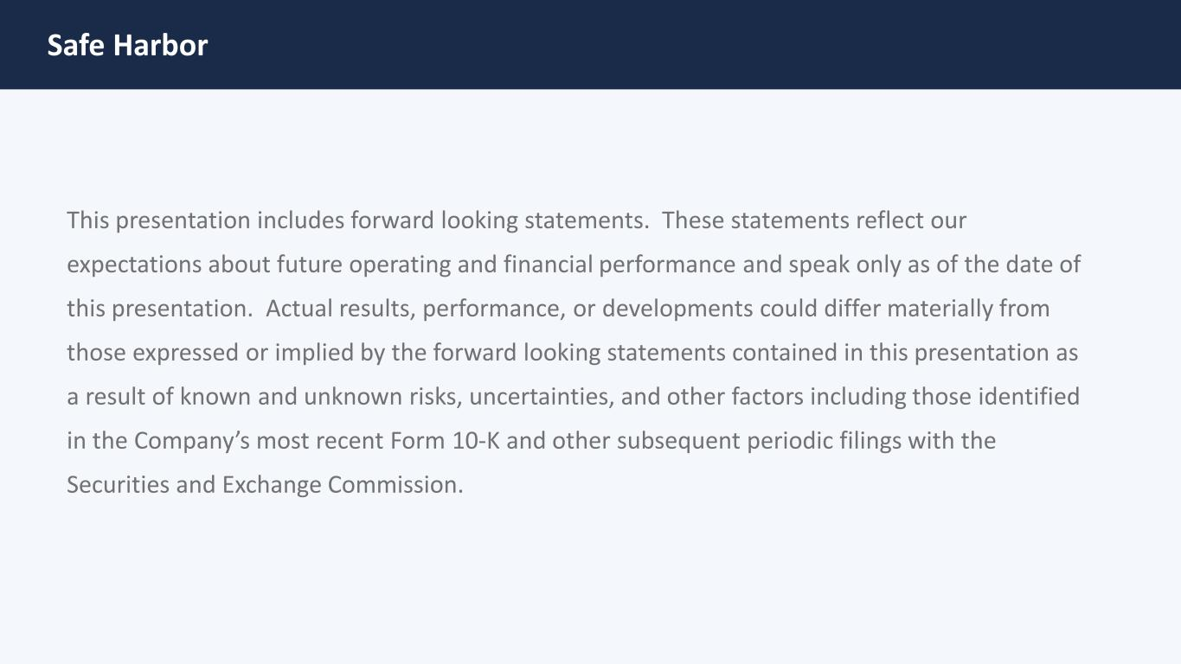
Safe Harbor This presentation includes forward looking statements. These statements reflect our expectations about future operating and financial performance and speak only as of the date of this presentation. Actual results, performance, or developments could differ materially from those expressed or implied by the forward looking statements contained in this presentation as a result of known and unknown risks, uncertainties, and other factors including those identified in the Company’s most recent Form 10‐K and other subsequent periodic filings with the Securities and Exchange Commission.

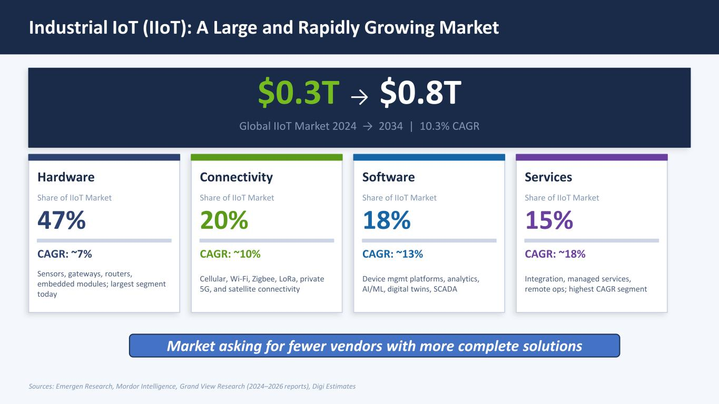
Industrial IoT (IIoT): A Large and Rapidly Growing Market $0.3T → $0.8T Global IIoT Market 2024 → 2034 | 10.3% CAGR Hardware Share of IIoT Market 47% CAGR: ~7% Sensors, gateways, routers, embedded modules; largest segment today Connectivity Share of IIoT Market 20% CAGR: ~10% Cellular, Wi-Fi, Zigbee, LoRa, private 5G, and satellite connectivity Software Share of IIoT Market 18% CAGR: ~13% Device mgmt platforms, analytics, AI/ML, digital twins, SCADA Services Share of IIoT Market 15% CAGR: ~18% Integration, managed services, remote ops; highest CAGR segment Sources: Emergen Research, Mordor Intelligence, Grand View Research (2024–2026 reports), Digi Estimates Market asking for fewer vendors with more complete solutions

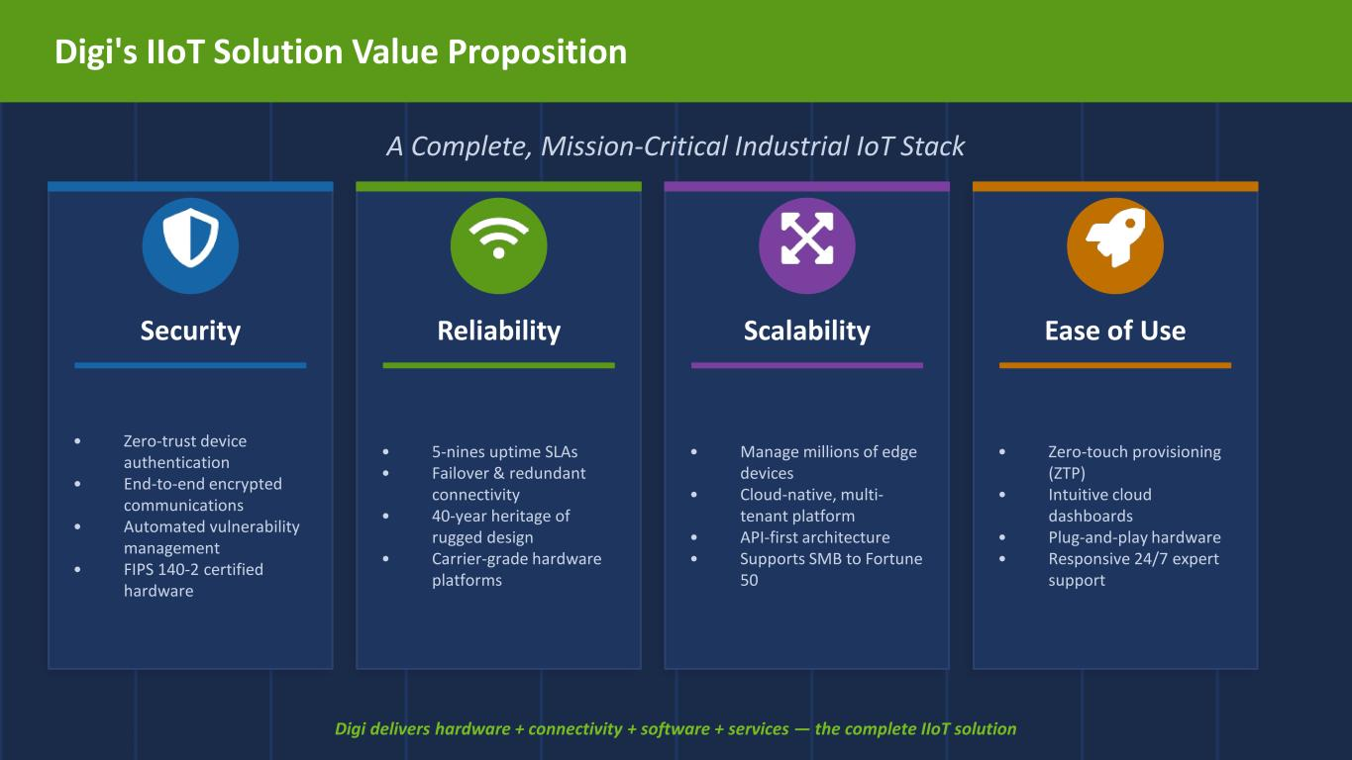
Digi's IIoT Solution Value Proposition A Complete, Mission-Critical Industrial IoT Stack Security • Zero-trust device authentication • End-to-end encrypted communications • Automated vulnerability management • FIPS 140-2 certified hardware Reliability • 5-nines uptime SLAs • Failover & redundant connectivity • 40-year heritage of rugged design • Carrier-grade hardware platforms Scalability • Manage millions of edge devices • Cloud-native, multi- tenant platform • API-first architecture • Supports SMB to Fortune 50 Ease of Use • Zero-touch provisioning (ZTP) • Intuitive cloud dashboards • Plug-and-play hardware • Responsive 24/7 expert support Digi delivers hardware + connectivity + software + services — the complete IIoT solution

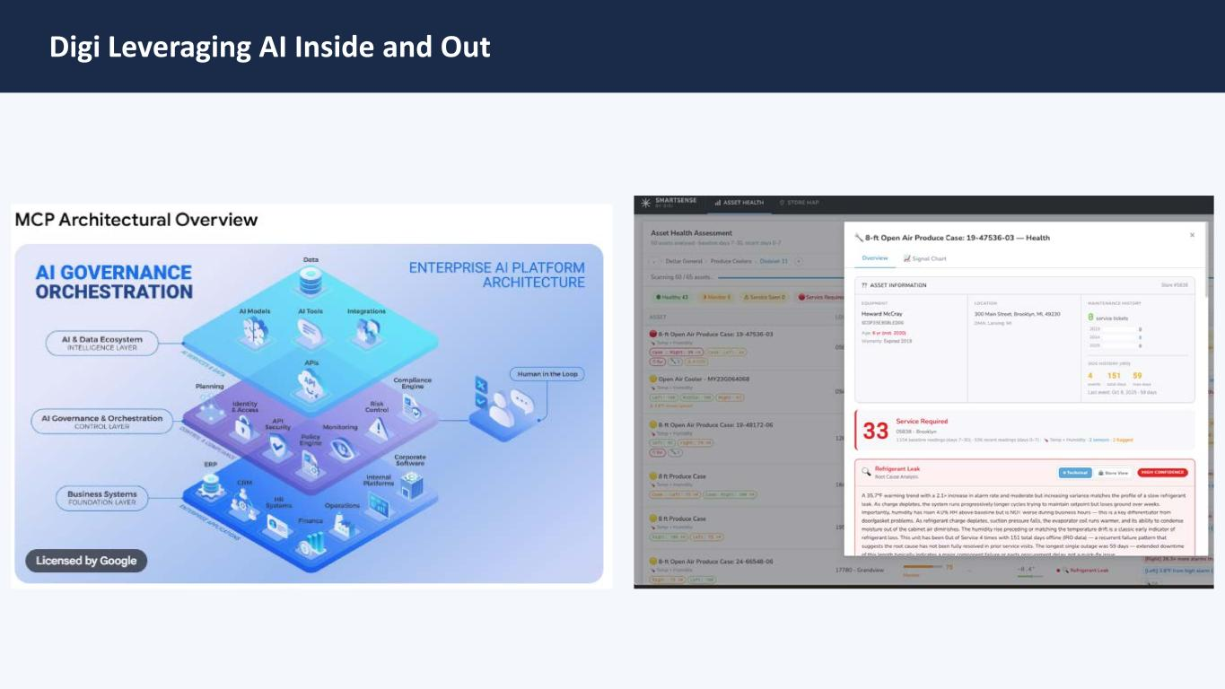
Digi Leveraging AI Inside and Out

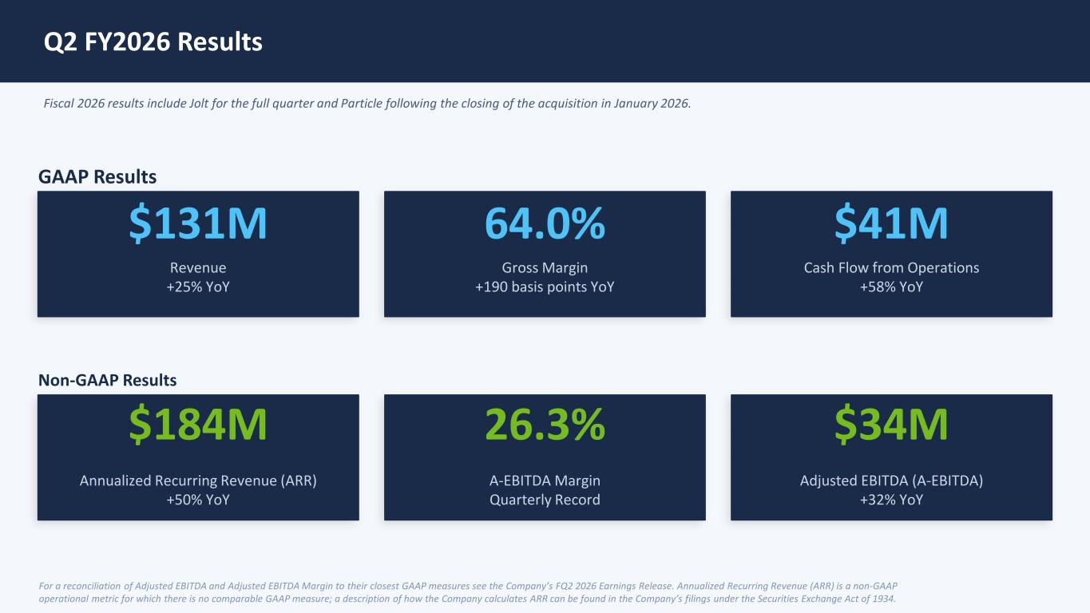
Q2 FY2026 Results Fiscal 2026 results include Jolt for the full quarter and Particle following the closing of the acquisition in January 2026. GAAP Results $131M Revenue +25% YoY 64.0% Gross Margin +190 basis points YoY $41M Cash Flow from Operations +58% YoY Non-GAAP Results $184M Annualized Recurring Revenue (ARR) +50% YoY 26.3% A-EBITDA Margin Quarterly Record $34M Adjusted EBITDA (A-EBITDA) +32% YoY For a reconciliation of Adjusted EBITDA and Adjusted EBITDA Margin to their closest GAAP measures see the Company’s FQ2 2026 Earnings Release. Annualized Recurring Revenue (ARR) is a non-GAAP operational metric for which there is no comparable GAAP measure; a description of how the Company calculates ARR can be found in the Company’s filings under the Securities Exchange Act of 1934.

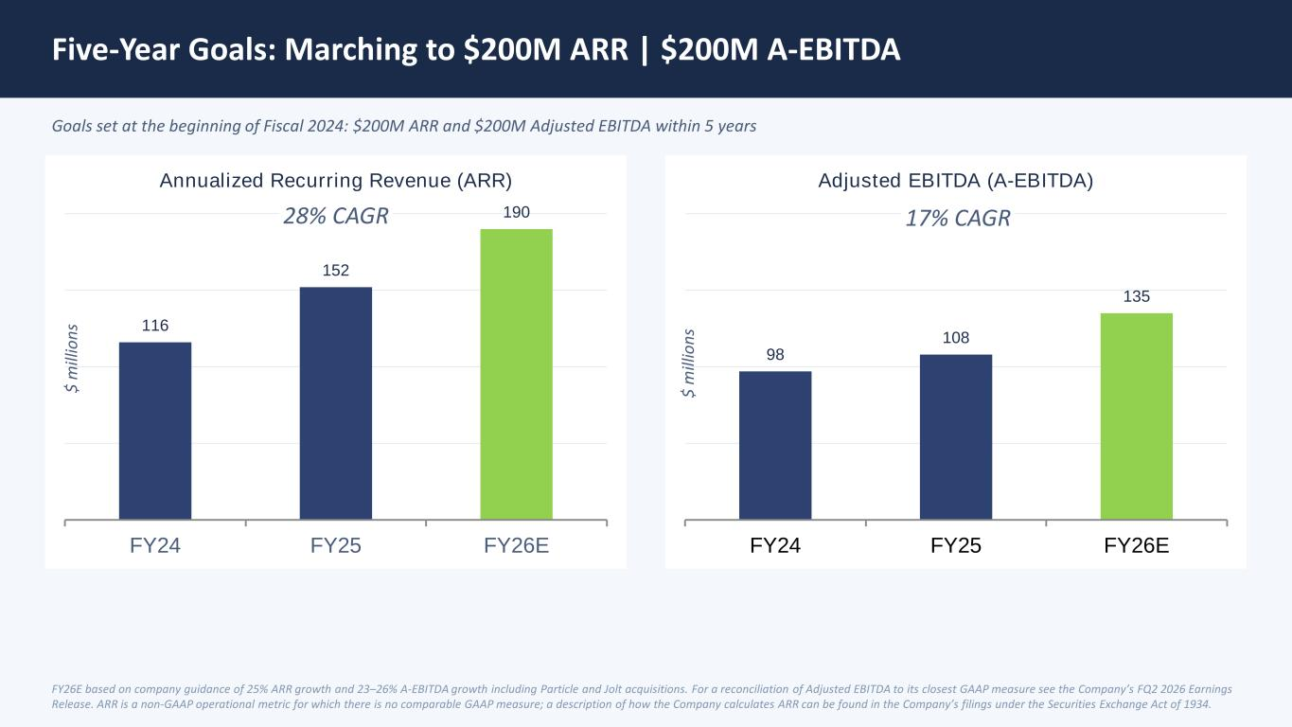
Five-Year Goals: Marching to $200M ARR | $200M A-EBITDA Goals set at the beginning of Fiscal 2024: $200M ARR and $200M Adjusted EBITDA within 5 years 116 152 190 FY24 FY25 FY26E Annualized Recurring Revenue (ARR) 98 108 135 FY24 FY25 FY26E Adjusted EBITDA (A-EBITDA) FY26E based on company guidance of 25% ARR growth and 23–26% A-EBITDA growth including Particle and Jolt acquisitions. For a reconciliation of Adjusted EBITDA to its closest GAAP measure see the Company’s FQ2 2026 Earnings Release. ARR is a non-GAAP operational metric for which there is no comparable GAAP measure; a description of how the Company calculates ARR can be found in the Company’s filings under the Securities Exchange Act of 1934. 17% CAGR28% CAGR $ m ill io ns $ m ill io ns

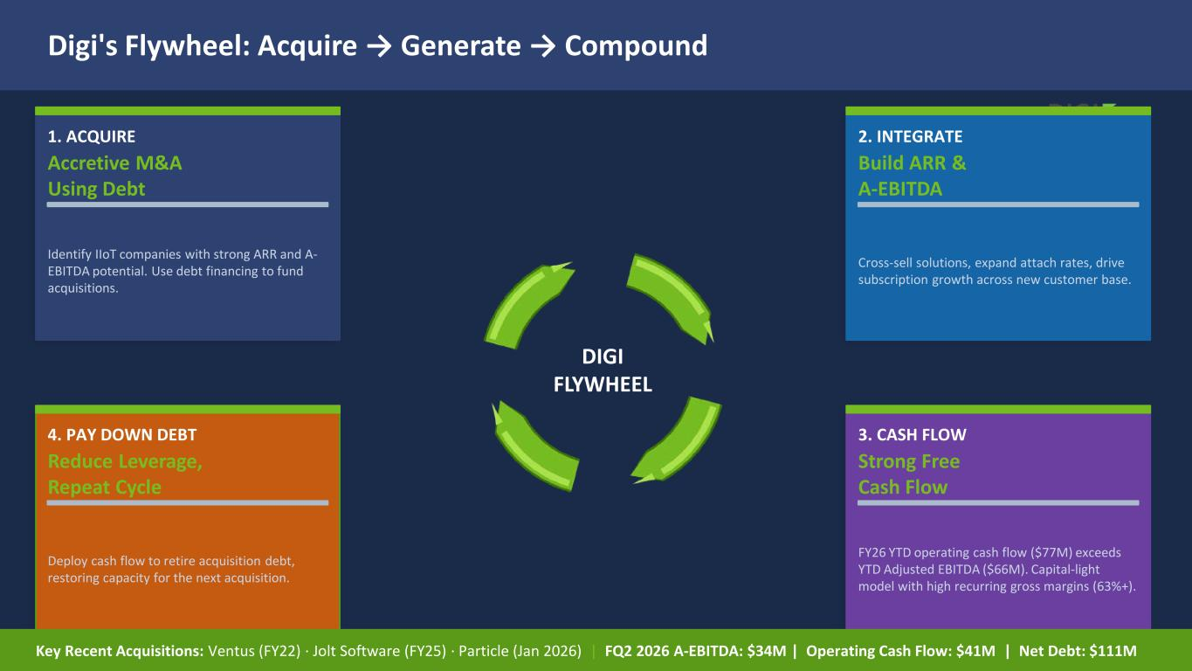
Digi's Flywheel: Acquire → Generate → Compound DIGI FLYWHEEL 1. ACQUIRE Accretive M&A Using Debt Identify IIoT companies with strong ARR and A- EBITDA potential. Use debt financing to fund acquisitions. 2. INTEGRATE Build ARR & A-EBITDA Cross-sell solutions, expand attach rates, drive subscription growth across new customer base. 3. CASH FLOW Strong Free Cash Flow FY26 YTD operating cash flow ($77M) exceeds YTD Adjusted EBITDA ($66M). Capital-light model with high recurring gross margins (63%+). 4. PAY DOWN DEBT Reduce Leverage, Repeat Cycle Deploy cash flow to retire acquisition debt, restoring capacity for the next acquisition. Key Recent Acquisitions: Ventus (FY22) · Jolt Software (FY25) · Particle (Jan 2026) | FQ2 2026 A-EBITDA: $34M | Operating Cash Flow: $41M | Net Debt: $111M



